|  |
| --- |
|  |
| <SLO Wayfinding>  Statement of Work |
| [Student Life Office] |
|  |
| **Nate Chiang**  **Castiel Li**  **Ron Tran**  **Quincy Lam** |
|  |

|  |
| --- |
|  |

**Table of Contents**

1. Document Version 3

2. Team Contact Information. 3

3. Description 3

4. Proposed Solution 4

5. Stakeholders 4

6. Proposed Technology 4

7. Assumptions 5

7.1. Non-Technical Assumptions 5

7.2. Technical Assumptions 5

8. Requirements 5

9. Deliverables 5

10. Out of Scope 6

11. Existing System 6

12. Diagrams 7

12.1. Client Diagrams 7

12.2. Team Diagrams 7

13. High-Level Schedule 8

14. High-Level Work Breakdown Structure (WBS) 8

15. Risks and Issues 9

## Document Version

|  |  |  |  |
| --- | --- | --- | --- |
| **Version** | **Description** | **Date** | **Author(s)** |
| **1** | *Created* | *23/09/2017* | *Chonjou Chiang*  Castiel Li  Ron Tran |
| **2** | *Revised Based on Client and supervisor suggestions. The main part of change is the out of scope session of the document.* | *29/09/2017* | *Castiel Li* |

## Team Contact Information.

TEAM 25

Supervisor: Donna Turner

|  |  |  |
| --- | --- | --- |
| Member Name | Email address | Phone |
| Castiel Li (Project Manager) | castiel.andrew@gmail.com |  |
| Quincy Lam | [quincylam@hotmail.com](mailto:quincylam@hotmail.com) | 604-319-8830 |
| Nate Chiang | [chonjou@gmail.com](mailto:chonjou@gmail.com) | 604-704-5442 |
| Ron Tran | [ronnotran97@gmail.com](mailto:ronnotran97@gmail.com) | 604-441-3645 |
| Donna Turner (Supervisor) | dturner80@bcit.ca |  |

## Description

* A web application that presents all BCIT Student Services currently provided for student who is unfamiliar about those services. In the meeting, we were told that many BCIT students did not access all the services they needed. One of the reason is because the current BCIT website split those services into many sub sessions. This is great for presenting detailed information to students, however, it also makes access overall information about all the service difficult.
* The BCIT Student Life Office (SLO) wants to make this web application to raise student’s awareness about BCIT Student Services. Also, with part-time students and new students, who cannot make it on orientation day, they can use this app to get information about all of services that are available in BCIT.
* The web application will be very simple and easy to use. User will be able to access all basic information regarding the services. (Operation hours, contact information, location etc) In addition, if student would like to learn more detail of those service, we will provide the link from BCIT website for them to visit.

## Proposed Solution

We decided to create a single page web application to solve the problem. We will use the category icons that provided by SLO as our main page. When a user clicks on them, all the services that are part of the category will be displayed. When the user clicks on one of those services, it will display some basic information (brief description, operation time, location, website and a student video that provided by SLO office. There will be also a search bar where students can search for the service they were looking for. Our intent is to give student a shortcut/gateway to access the services they need; therefore, we will contain our page within three clicks.

## Stakeholders

* BCIT Student Life Office(SLO)
  + SLO is our client for this project, they need a web application that is easy to use, cover all type of students and provide information of all the service BCIT have for their students.
  + Contact Info: student_life@bcit.ca
* BCIT Students
  + The BCIT students will be our primary users. This includes all the students, part-time, full-time, distance etc. They need a easier and faster way to find all the service they can access from BCIT.
* Potential Students
  + Some potentials students may want to know they service they can get if they chose to study at BCIT.

## Proposed Technology

For this project, we are decided to use React as our main scripting language. We will also use CSS, HTML, and one of the database. We have not yet decided on what database we will be using now. React is the best fit for our single page application, it loads everything at once and displays information base on the filter we provided. We will be able to speed up the loading time for the application by a significant amount of time. Since there might be many pics being implement in the future and this will be a handy informational website, the fast loading speed will help us improve user experiences.

## Assumptions

## Non-Technical Assumptions

1. The client will provide us with the information to display
2. The client will provide us with videos to create a student to student voice
3. The client will take care of future changes of content display on the websites. (We will provide easy method to do this. Castiel can provide help if needed during his school year)

## Technical Assumptions

1. The student team will determine the back-end and front-end technologies;
2. Project web site will use React.js, CSS, HTML.
3. The team will oversee the design and development of the GUI
4. The current BCIT IT service department will allow React.js being used
5. The new web application will be compatible to current BCIT websites

## Requirements

* Features
  + Search Bar
  + Video for each service if provided by SLO
  + Eight category icon which is clickable and will expend into all service under that category
  + Mobile friendly
  + Fast loading and responding time
  + Access all the information within three click from the main page
  + Desktop friendly
  + Chrome and Firefox browser friendly

This application will be fully functional by the end of the project, it means we will implement everything SLO provided up and have it ready to launch. We will finish the design, implementation, and testing stage. We will not be able to launch the application because we do not have the access to BCIT IT service. The client is in charge of contacting the IT service and host our website.

## Deliverables

|  |  |
| --- | --- |
| **Deliverable** | **Description** |
| UI/UX design | The team will provide the client with a design that will is consisted of three panels on desktop and a singular one in mobile. |
| Front end of the application | The team will also oversee the development of the UI/UX design. |
| Responsiveness on the latest device on Android and iOS | The team will focus their efforts on two devices one for each operating system. The team will not try to achieve responsiveness on every device and every browser, only the most common ones. |
| Easy method to change the data in the future | Since the information may need to update on regularly base, we will make sure the process of updating information is easy and fast. |

## Out of Scope

After having two meetings with Student Life Office (SLO), we realized that there are some features that we might not be able to do:

1. Plug our web application into D2L
2. Our app will not be fully responsiveness
   1. We can’t cover all the device and all the browser due to the different behavior of browsers towards React.js; however, the majority of browser and device will be covered.
   2. We will test our website on
      1. Chrome, Firefox in terms of browser.
      2. iPhone 6, Nexus 6p in terms of device.
3. Student tour feature
   1. Depends on the completion time of the project, we might be able to implement the student tour feature. This feature will allow a new student to have a guide tour of basic/important service that they can access as a student at BCIT.
4. The deploying and hosting part of the project will be taken care of by BCIT IT services.
   1. This means that will provide all the codes for the website, but hosting and plug into BCIT current website will be done by BCIT IT services department. The season behind this is that we do not have the access to BCIT server. We will be there to answer any question related to our project.
5. The product will not be having a database. We have decided that the web application will not be contain a database since the information we need is relatively small. We will use either a Json document or something similar contain the information. This means that changes can be easily made by someone who doesn’t have a computing background. Training might need for short amount of time.

## Existing System

The existing system is BCIT welcome page (<https://www.bcit.ca/welcome/>). The website contains many detailed information about student services that is being provide by BCIT; however, due to the huge amount of information. Student found it difficult to learn all the service they can access as well as just some basic information about those services. The current WayFinding Guide(<https://www.bcit.ca/files/lifeatbcit/pdf/student-services-wayfinding-guide-2017.pdf>) is great in term of giving students a brief description of each services in BCIT. However, it does not have the information student would need for accessing those service. (Operation hours, Contact information etc).

The new system we are building will have some details of each service which just enough for them to access the services they need.

## Diagrams

## Client Diagrams

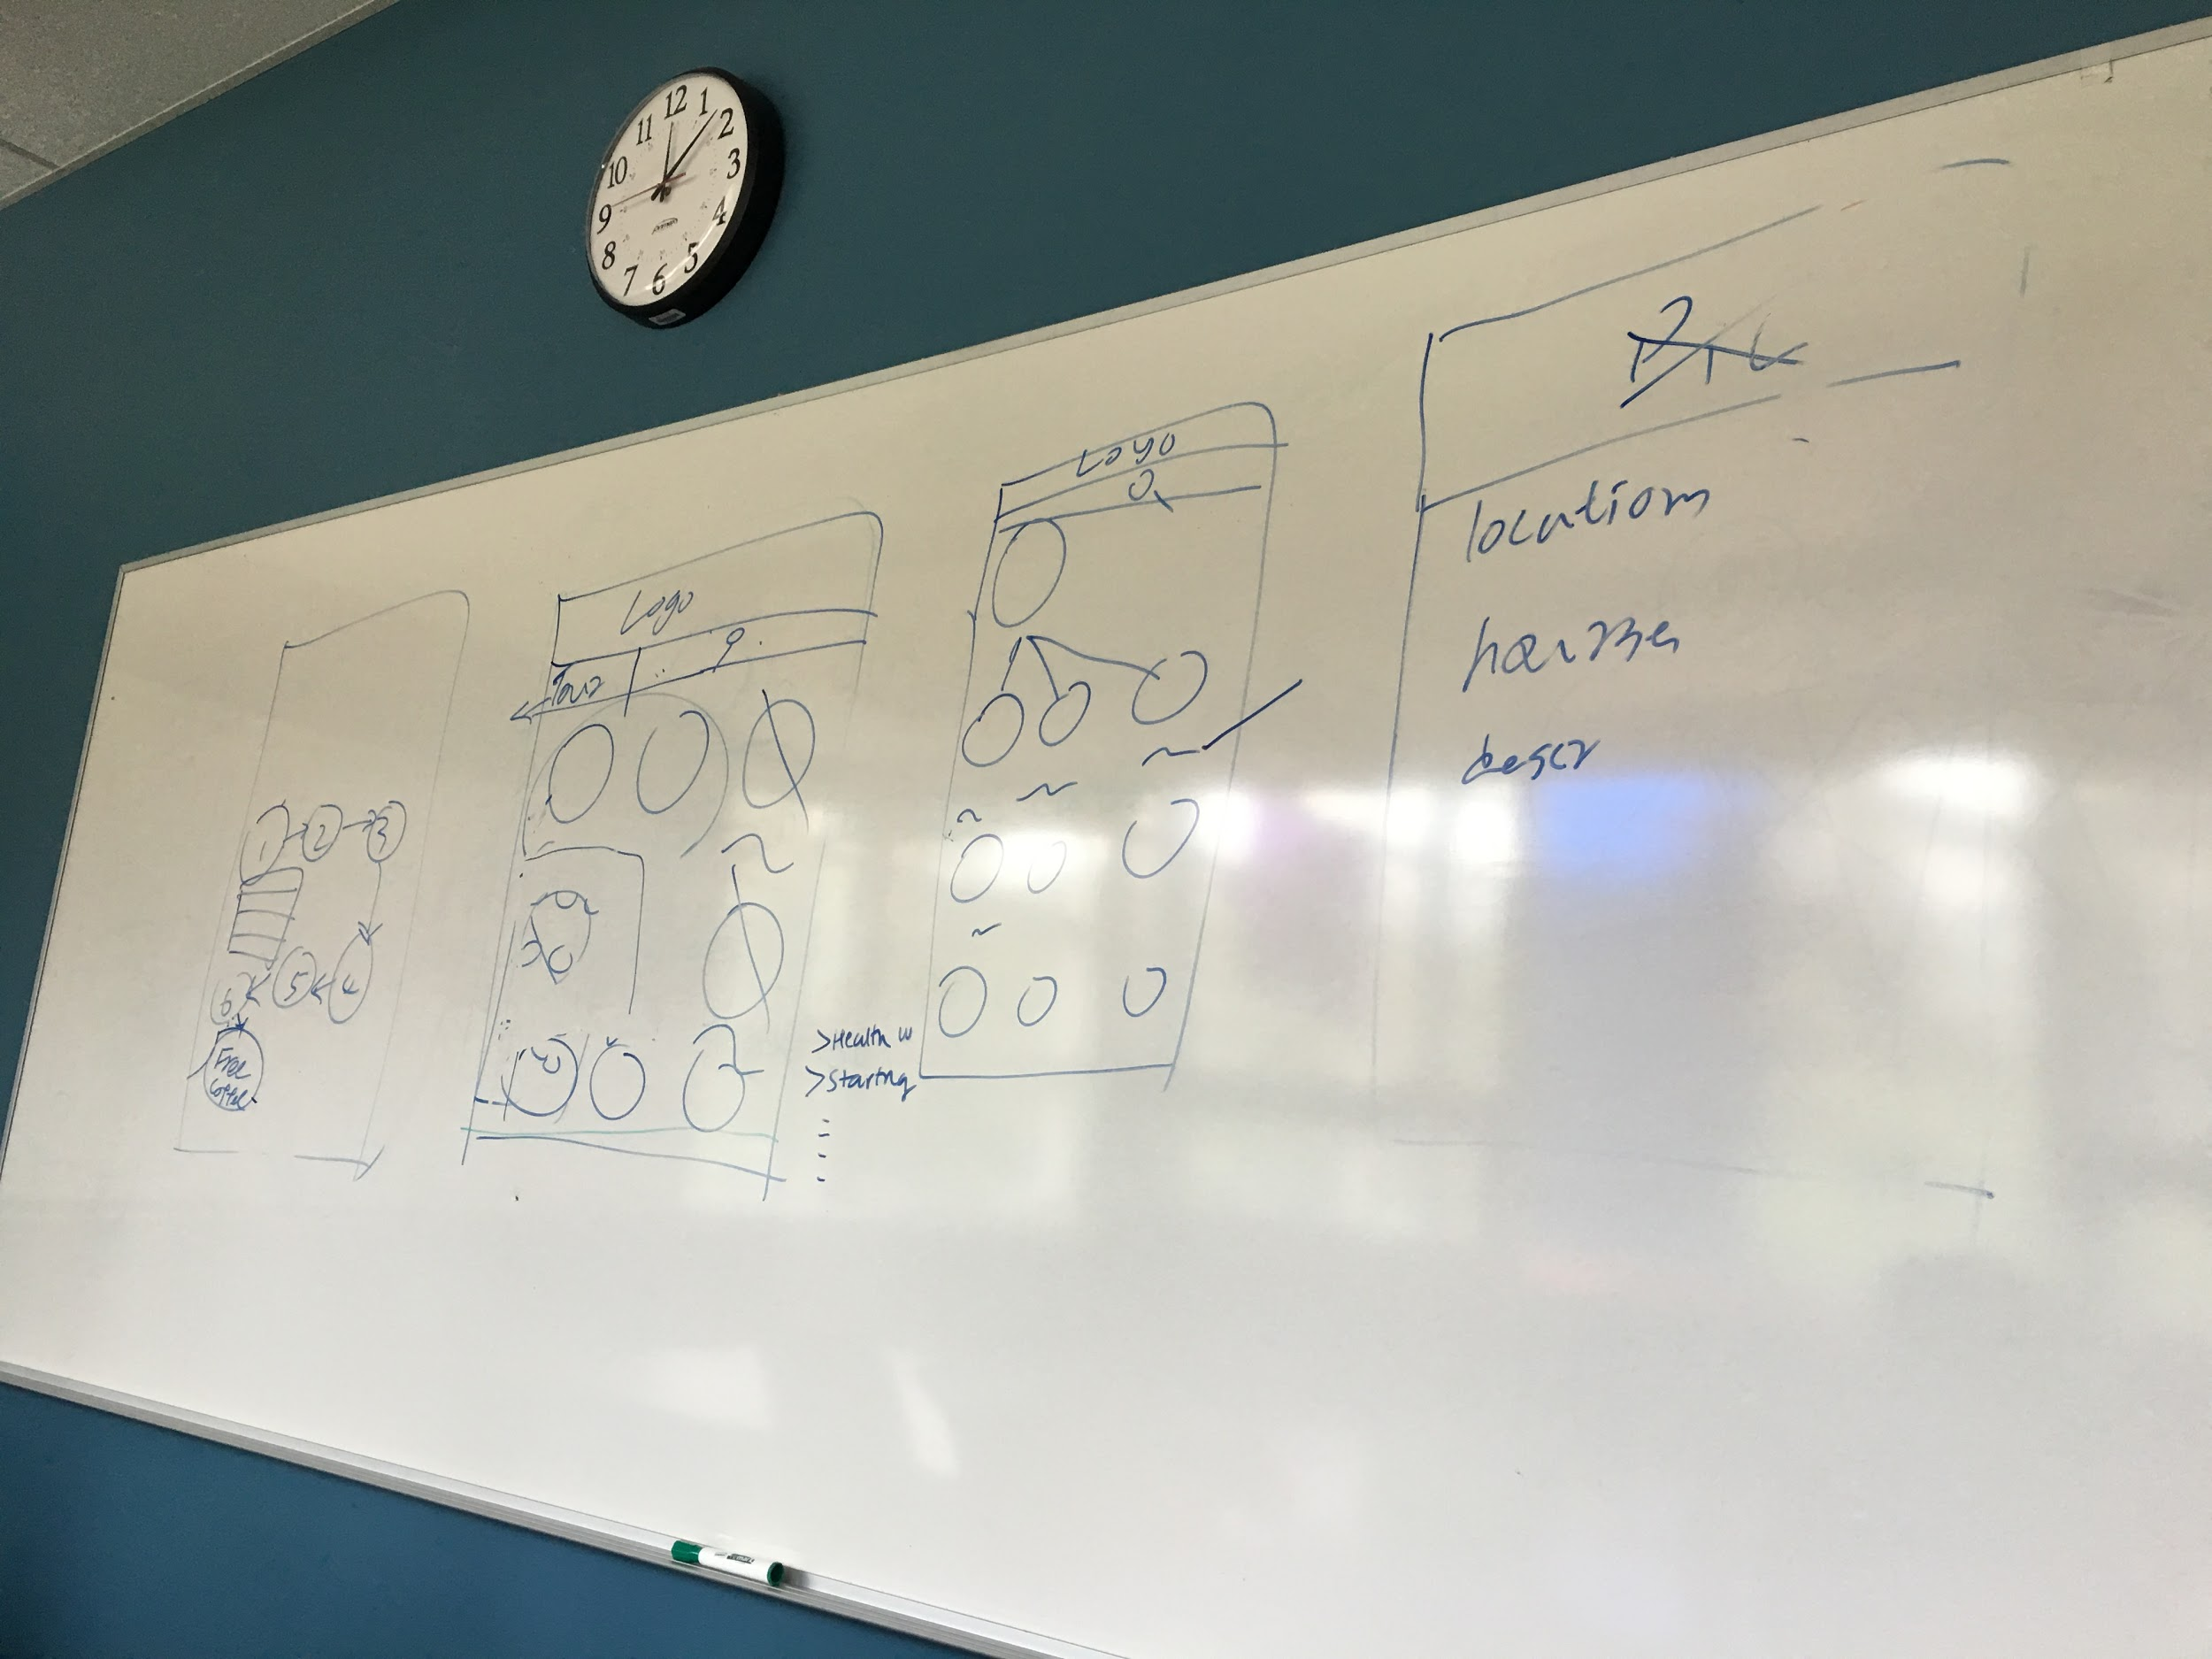

This diagram was produced with the help of the client to portray the basic structure of the final product.

## Team Diagrams

The following diagrams is the prototype we have designed for this project

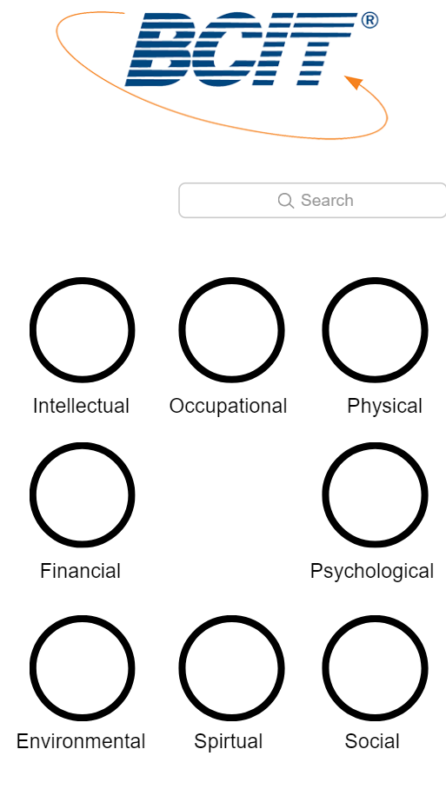  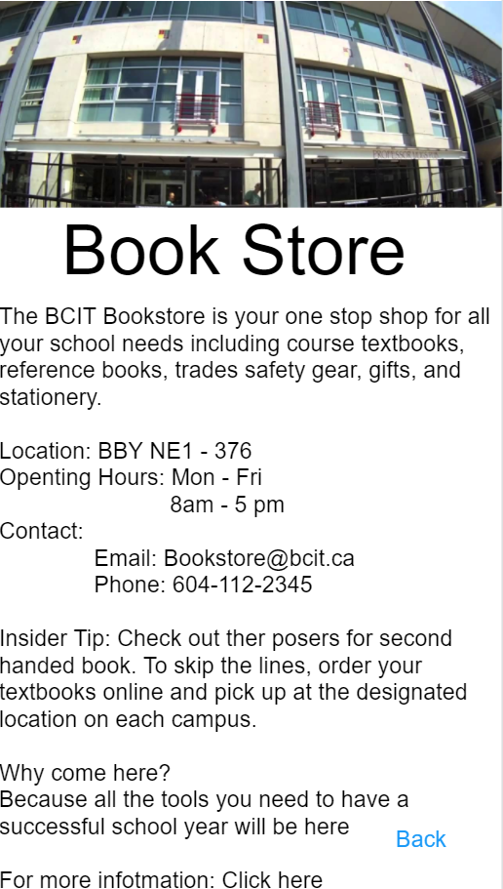

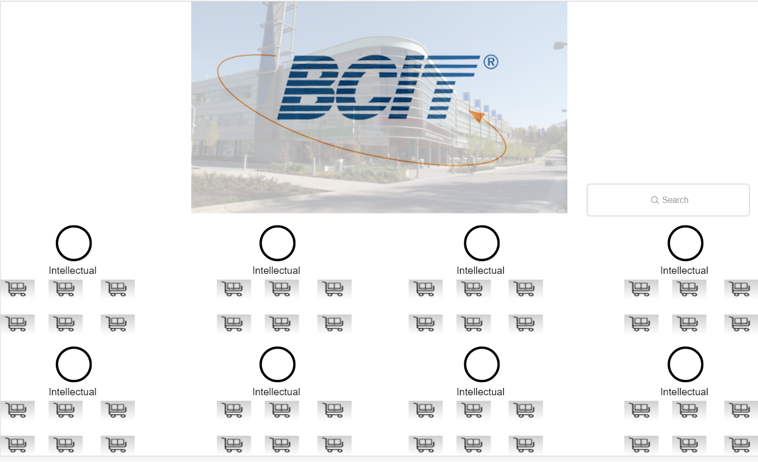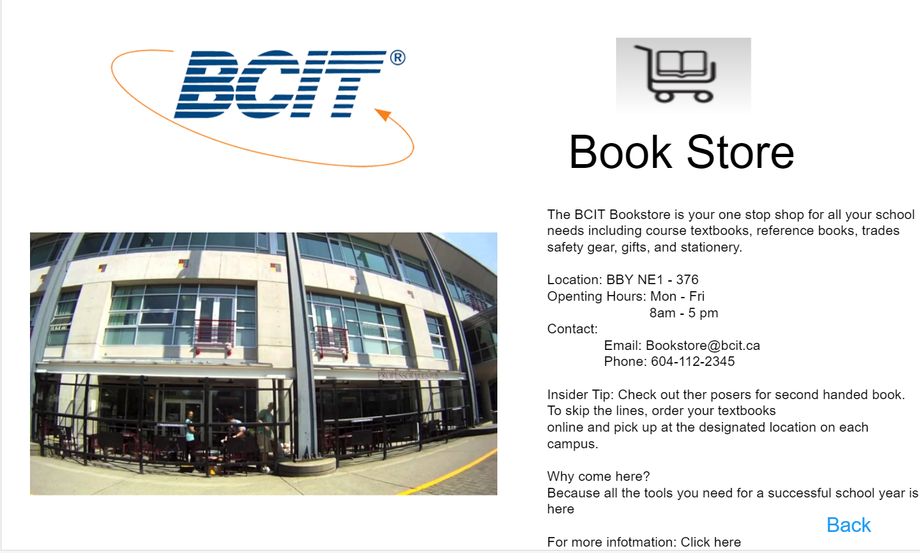

## High-Level Schedule

1. UI/UX design of the front end of the web application
2. Setting up of the React.js framework
3. Begin the coding of the front-end.
4. Once finished go over the front-end with the client and polish further via email and weekly meeting (Our client is on campus which makes the communication much easier for us)
5. Repeat steps 3 and 4 until all the requirements and the client is satisfied with the look of the application
6. Depending on the completion date of the project, we might implement the tour guide as well.

## High-Level Work Breakdown Structure (WBS)

|  |  |  |
| --- | --- | --- |
| **Owner** | **Description** | **Completion Date** |
| Nate Chiang | Decide Database will be used for the application | September 30, 2017 |
| Castiel Li | Develop prototype for client. | September 30, 2017 |
| Ron Tran | Study and learn ReactJS for project | September 30, 2017 |
| Quincy Lam | Study and learn ReactJS for project | September 30, 2017 |
| Castiel Li | In charge of setting up meeting | Ongoing |
| Castiel Li | In charge of document meet due dates | Ongoing |
| Quincy Lam | Take notes during meetings | Weekly |
| Nate Chiang | Set up git repo for the application | September 30, 2017 |
| Team | Basic layout with place holders | Oct 7, 2017 |
| Castiel Li | Keep track of estimate time and actual time differ | Weekly, Ongoing |
| Castiel Li | Fill the meeting minutes form | Weekly, Ongoing |
| Castiel Li | Revise Statement of Work based on both supervisor and client meetings | Oct 1, 2017 |
| Castiel Li | Draft for Stage 2 plan | Oct1, 2017 |
| Castiel Li | Update Risk & Tech issues table | Weekly, Ongoing |
| Castiel Li | Complete Project Proposal | Oct1, 2017 |
| Castiel Li | Complete Testing plan and revise | Oct1, 2017 |
| Castiel Li | Complete Test Case documents | Oct1, 2017 |
| Team | Test the product with test case list in test case documents | Weekly, Ongoing |

## Risks and Issues

|  |  |  |
| --- | --- | --- |
| **Risk or Issue Description** | **Potential Impact** | **Mitigation/Resolution Steps** |
| Developing features that is not what client needs | Significant impact | Establish all requirements first before starting project |
| Cannot complete all the requirement in time | Significant impact | Analyze all the features and determine if they are within our skill set |
| Unfamiliarity with new technologies | Medium impact | Get familiar with React.js as soon as possible |
| Need to change technologies during the development stage | Significant impact | Analyze all the features and compare them with Reac.js documentation. |